**Patent Application File**

By: **Cindra Zakaria**. February 10, 2021 15:01:16

Patent Application File

1. Guidelines for Paper Size Limits and Writing Procedures for Creating Patent Specifications
2. Abstract Sample
3. Claim Sample
4. Description Sample
5. Patent Image Template sample (if any)
6. Declaration of Ownership of Invention
7. Letter of Transfer of Rights to Invention (to UNG)
8. 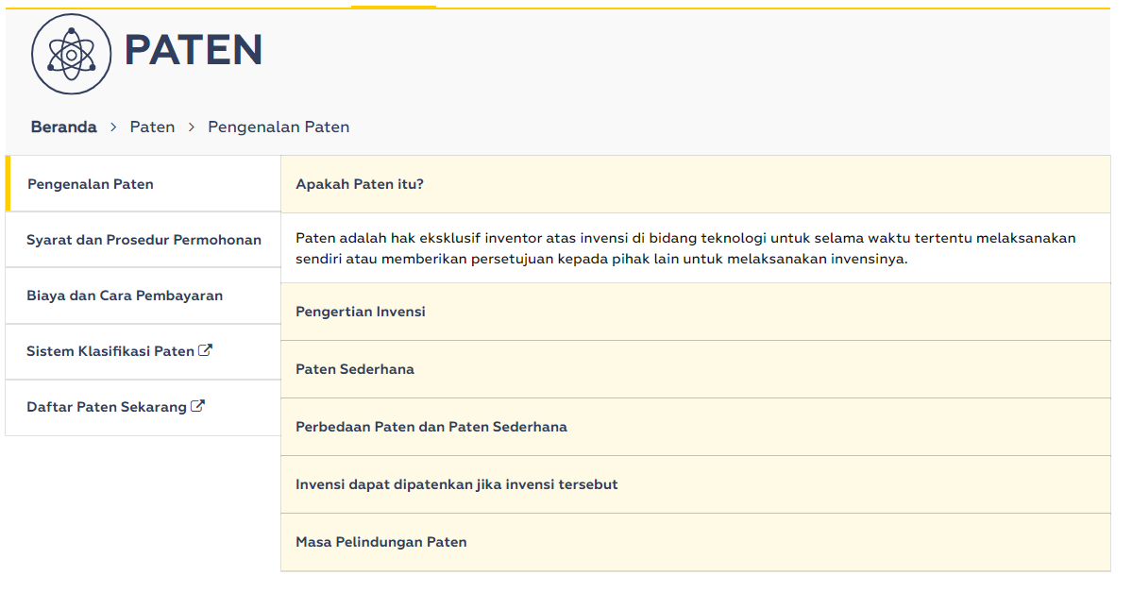Others (Fees and Procedures)